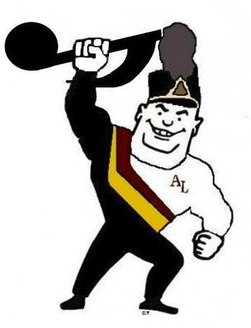
PATRON DRIVE
ALHS Band Aids, Inc.
We are all Band Boosters!

ALHS Band Aids, Inc. has been in existence since 1964 to provide financial support and assistance to all Avon Lake City Schools bands in grades 5 through 12. Money raised by Band Aids is used for:
½-priced music lessons at Troy and Learwood; local field trips and large-scale high school trips, like the Symphonic band’s trip to play at NYC’s Carnegie Hall; scholarships for music education programs; instruments; equipment; uniforms and concert attire; and more!

Please show your support by contributing to the Patron Drive.

_____ $25 – Bronze Please print your name below as you would like
it to appear in our programs:
_____ $50 – Silver
_______________________________________
_____ $100 – Gold

_____ More than $100 – Platinum _____ I would prefer to remain anonymous

Donation Amount ________ Check # _________

Thank you! Your support is essential to our instrumental music program!
All donations are tax deductible.
Please make checks payable to ALHS Band Aids, Inc.
Return to ALHS Band Aids, Inc., c/o Lisa Rish, 31847 Hazelwood Lane, Avon Lake, Ohio, 44012.

Anonymous in the program or not, please let us know who you are so we can thank you!

Name: ___________________________________________________________________________

Address: _________________________________________________________________________

City: _______________________________________ State: __________ Zip: __________

Phone and/or e-mail: __________________________________________________________

Student’s school: Troy _______ Learwood _________ High School _______

_____ I don’t have a band student, so I don’t receive the newsletter. Please keep me informed by e-mailing the Band Aids newsletter to the above e-mail address!

_____ I am an ALHS Band alumnus. (Please write your name below, if multiple names are listed above. Also, include maiden name if applicable.) ______________________________________________________________ ♪♪♪♪♪♪♪♪♪♪♪♪♪♪♪♪

